Winter Weather Ahead!
Schools are not routinely closed due to snow or other inclement weather conditions. All schools in School District 43 (Coquitlam) will remain OPEN, if at all possible, during winter weather, including snowfall.

However, on occasion, a district-wide or partial-district closure is required due to extreme weather. Partial-district closures affecting individual schools may occur due to the very different geography within our school district. If there is a partial-district closure affected schools will be identified.

The decision on schools remaining open or needing to be closed, because of extreme weather, occurs before 6:30 a.m. so that families can plan and make alternate arrangements.

Any district-wide or partial-district closure will be decided and communicated by 6:30 a.m. via the School District 43 website www.sd43.bc.ca and CKNW AM 980 radio, CKWX 1130 radio and CBC (690) radio.
While the District tries to make the best decision with the information available, the weather does change quickly. Therefore, when schools remain open, decisions to stay at home during challenging weather conditions should be made by each family.

Extreme weather can also impact transit. Transit schedules may face significant changes or cancellations due to the weather conditions. Parents seeking information on transit schedules need to consult the Translink website: http://www.translink.ca/

We encourage families to continuously check the School District 43 website for updates and changes: www.sd43.bc.ca

Learn more about SD43’s process for emergency and inclement weather status updates at: http://www.sd43.bc.ca/NewsEvents/Pages/EmergencyInformation.aspx

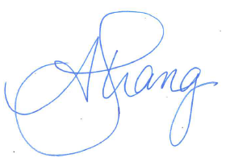
Sincerely,

Anita Strang
Principal
Parkland Elementary

